**The Effect of Journalist Mistrust and Hostile Sexism on Perceived Realism of Female**

**Journalist Exemplars**

Stephanie Cobble, K**** B****, A**** C****, V**** R**** M****, N**** M****

University of Washington Tacoma

[cobbles@uw.edu](mailto:cobbles@uw.edu), [k****@uw.edu](mailto:k****@uw.edu), [a****@uw.edu](mailto:a****@uw.edu), [v****@uw.edu](mailto:v****@uw.edu), [n****@uw.edu](mailto:n****@uw.edu)

**Abstract**

In the media and entertainment industry, an alarming trend revolves around female reporters that employ sexual behaviors to get desired information from male counterparts unethically. This is troublesome for the reasons that it leaves real-life women in a vulnerable and targeted position, where they are harassed, assaulted, and discriminated against. This begs the question of who among viewers is more inclined to assume that these unethical sexist themes are realistic in the real world. Stereotypes about female journalists, hostile sexism, and journalist mistrust were all found to be significant determinants in perceived realism in a pre-registered poll (N=580). Because perceived realism is thought to support the impact of the media, these results suggest that viewers that score highly in stereotyping or sexist beliefs are the most prone to being affected by sexualized depictions of journalism. Therefore as predicted, hostile sexism, female journalist stereotypes, and mistrust in journalists, had a significant positive correlation with the perceived realism of sexual depictions of female journalists.

**The Effect of Journalist Mistrust and Hostile Sexism on Perceived Realism of Female**

**Journalist Exemplars**

Of the 600 female journalists that partook in a 2018 survey, more than half reported that they had been threatened, harassed, or physically assaulted over a twelve-month period, and nine out of ten of these women said this was a worsening issue in the previous 5 years leading up to this survey. (Thomson Reuters Foundation, 2018). There is no question that female Journalists are subjected to a variety of different forms of abuse during their professional careers. There is still much to be understood about what causes female journalists to be predisposed to the high rates of abuse they encounter in their professional careers, although there are some existing theories that may help to explain this phenomenon.

One of the main circulating theories surrounding this issue is that the way female journalists are depicted in entertainment media is what causes people to treat them the way that they do. Female journalists are often misrepresented by various entertainment media, and often are depicted using unethical means to obtain information for their reports, and more often than not, this involves using sexual favors to get information for their stories. This perpetuates an image that female journalists are sexually promiscuous, and will do anything for a good story. Hollywood plays a role in reinforcing this idea that female journalists will sleep with anyone from their bosses to their sources to get to the top, despite what actual journalists report (Freeman, 2015; Gilbert, 2018). These are the images that people are exposed to so often by Hollywood, and consequently they are the images that come to mind when they think of female reporters.

There are also available theories that suggest why these images may alter the way individuals treat female reporters in the real world. Theories from the domain of media psychology say that these images can alter behavior due to both overgeneralization from memorable examples (e.g., Zillmann, 2002) and because these images are so cognitively accessible due to the long-term exposure to these images (e.g., Morgan & Shanahan, 2010).

Given that the perceived realism of these media images directly affects levels of harassment that female journalists are faced with, there is much importance to finding a relationship between various participant characteristics such as their levels of hostile sexism and their mistrust of journalists and how realistic they believe these images to be.

Our hypotheses are 1)There will be a positive relationship between hostile sexism and external realism, 2) There will be a positive relationship between agreement with female journalist stereotypes and external realism, 3) There will be a positive relationship between mistrust in journalists and external realism, 4)Mistrust in journalists, agreement with female journalist stereotypes, and hostile sexism will collectively predict a statistically significant incremental portion of variance in external realism relative to the variance explained by sex and ideology.

**Mistrust towards Journalists**

The measurement of trust was at the level of journalist rather than with the level of specific sources or the media. Previous studies however, had suggested that the measurement of trust depended whether the questions pertained to trust in the media than a specific media source. The reasons being is a large body of work has examined the factors that contributed to the perceptions of media trust (e.g., Jackob, 2012; Kohring & Matthes, 2007; Lee, 2010; Tsfati, 2010). ) And typically, the past work on media trust placed the locus of measurement at the level of the media organization (e.g., Kohring & Matthes, 2007) or the press in general (e.g., Peifer, 2018). Furthermore, the media content's perceived realism has long been acknowledged as an important aspect in the research of media effects (e.g., Busselle & Greenberg, 2000; Hall, 2003; Hawkins, 1977; Potter, 1988). However, from the general perspective trust in the media was not necessarily consistent with the trust in specific sources. (Daniller, Allen, Tallevi, & Mutz, 2017). Rather, it seems more reasonable that perhaps trust towards journalists might also be more distinct from trust in media. In this case, the measurement of journalist distrust is likely more effective than measurement of media trust in general. Although, the more the measurement of journalists distrust the more attempts there are to tap into common hostile stereotypes of journalists, such as specific stereotypes of female journalists. Female journalists are criticized and depicted negatively in the media (e.g., Painter & Ferruci, 2017). Typically, they are being depicted by using their appearance or sexual prowess to prevail the facts they need for a big story. Applied to the present-day study, the perceptions of perceived realism are likely to be shaped by the general distrust of journalists, specifically with the sexist beliefs and stereotypes about female journalists.

**Stereotypes of Female Journalists**

Furthermore, the stereotypes and negative presentation of female journalists are unsafe. They are not safe in the fictional storylines that abound in television dramas and popular films. Female journalists are frequently depicted in popular media in a “grotesquely insulting” plot story in which they utilize their sexuality to entice male sources in order to “get the scoop” and improve their careers. (Rosenberg, 2013) These stories frequently end with the female reporter receiving a harsh reprimand, such as firing, social banishment, or even death at the hands of their male informant. Additionally, Hollywood's penchant to portray female reporters as "poisonous and promiscuous" and is "creating a toxic environment for genuine journalists," according to working female journalists (Gilbert, 2018). The way female journalists are portrayed in fiction has an impact on how they are treated in real life. These effects are thought to arise from a combination of overgeneralization and memorable examples, according to media psychology (e.g., Zillmann, 2002) In response, female journalists recognized that how they are treated in real life by some members of the public is likely influenced in part by how their fictitious counterparts are portrayed in entertainment media. This possibility seems likely given that exposure to sexualized depictions of women has been linked to negative results such as dehumanization of women and endorsement of the rape myth in previous studies (e.g., Ward, 2016). And through cognitive accessibility aided by long-term media narrative exposure that denigrates women. (e.g., Morgan & Shanahan, 2010) As predicted by previous research, the current study contributes to theory by putting schema and stereotypes to the test as predictors of realism (e.g., Busselle & Bilandzic, 2008). The current research examines the perceived realism of fictional journalists with sexualized behavior and appearance. The two possible sources of schema-relevant knowledge when dealing with this attitude object: (1) pre-existing ideas about journalists and (2) pre-existing views about women.

**Hostile Sexism**

Another element that is expected to impact realism judgments of fictional female journalists are spectators’ present viewpoints that an individual possesses towards women. Hostile sexism is a conflicting outlook of gender relationships in which women are thought of as trying to have dominance and power over men, whether that be through sexual means or feminist ideas (Glicke & Fiske, 2001). Hostile sexism is also a secondary kind of inconclusive sexism that is distinguished by prejudicial viewpoints toward women that results from recognized issues by women in opposition to dominant male focused power constructs (e.g., Glick et al., 2000). More precisely, previous studies have discovered that hostile sexism is made up of gender distinction, sexual attitudes, and power acts (Glick & Fiske, 1996). Of utmost relevance to this study are aspects associated with dynamics of power and sexual nature. For instance, Glick and Fiske (2001) point out that men very frequently feel a sense of hostility toward women because they resent women’s perceived ability to use sexual attractiveness to gain power over them” (p. 112). In addition, it is noteworthy that beliefs that correlate with hostile sexism are advocated for by both men and women (e.g., Becker. 2010). Pertaining to the current study, it appears reasonable to assume that a person who scores highly in hostile sexism, will be more likely to view fictional narratives in which the main character is depicted as using her sexuality to acquire information for a scoop. As expected, individuals that score highly in hostile sexism are more presumably to score higher in prejudice filled results and actions like sexual harassment (e.g., Begany & Milburn, 2002), rape myth acceptance (e.g., Chapleau, Oswald, & Russel, 2007) and lesser help extended for movements that would assist women (e.g., Becker & Wright, 2011).

*Hypothesis: We predict the following; there will be a positive relationship between mistrust of journalists and external realism,* *there will be a positive relationship between female journalist stereotypes and external realism,* *there will be a positive relationship between hostile sexism and external realism, and last mistrust of journalists, female journalist stereotypes, and hostile sexism will collectively predict a statistically significant incremental portion of variance in external realism relative to the variance explained by sex and ideology.*

**Method**

**Participants**

Participants were 580 individuals on Amazon’s Mechanical Turk (MTurk) crowdsourcing website (Mage= 36.41, SD= 14.565). The sample participant’s sex was 37.5% female and 62.5% male. The sample participant’s race was 18.6% Asian/American, 2.1% Bi-racial, 9.3% Black/African American, 5.9% Hispanic/Latino/Latina, .3% Other, and 63.6% White/Caucasian.

**Measures**

**Hostile Sexism.** Hostile Sexism was measured using Eleven Likert-type items measured on a seven-point scale (1 = strongly disagree, 7 = strongly agree). These Likert items were adapted from previous research (Glick & Fiske, 1996) which also aimed to measure hostile sexism. Sample items include “Women are too easily offended,” “Feminists seek to have more power than men”, and “Women do not appreciate all that men do for them.” The numerical value for all likert-type items were added together then divided by the total number of items in order to give an averaged total value for all questions giving a range of values for the total score.The higher a participant's average overall score on these Eleven questions, the higher level of Hostile Sexism they were assumed to have. See Appendix A.

**Stereotypes of Female journalists.** Four Likert-type items measured on a seven-point scale (1 = strongly disagree, 7 = strongly agree) were used to measure’ participants’ agreement with stereotypes regarding female journalists. Previous studies were looked at in order to come up with what common stereotypes were (Painter, C., & Ferruci, P. 2017). The four questions stated common stereotypes associated with female Journalists such as “Female journalists often trade sexual favors for “inside information” from a source.” The numerical value for all likert-type items were added together then divided by the total number of items in order to give an averaged total value for all questions. The higher a participant's total average score on these four questions, the more they were assumed to agree with stereotypes associated with female journalists. See Appendix B.

**Mistrust of Journalists.** Five Likert-type items measured on a seven-point scale (1= strongly disagree, 7 = strongly agree) were used to measure participants’ mistrust towards Journalists. This scale for measuring levels of mistrust in journalism was adapted from previous research (Kohring & Matthes, 2007) An example of one of the questions was “most journalists will do anything to get a story.” The numerical value for all likert-type items were added together then divided by the total number of items in order to give an averaged total value for all questions. The higher the averaged total score the participant had on these questions, the more mistrust in journalists in general they were assumed to have. See Appendix C.

**External Realism**. Five Likert-type items measured on a seven-point scale (1 = strongly disagree, 7 = strongly agree) were used to measure the perceived external realism of a video clip featuring unethical behavior by a female Journalist.This scale for measuring the perceived realism of the video clip shown was adapted from previous research (Busselle, R., & Greenberg, B. S., 2000). One sample question was “The video clip portrayed the same kind of behaviors that you would see a journalist do in real life.” The numerical value for all likert-type items were added together then divided by the total number of items in order to give an averaged total value for all questions. The higher a participant's total averaged score, the more they were assumed to believe that the video clip accurately depicts real world scenarios. See Appendix D.

**Procedure**

Before engaging in the survey, participants completed an informed consent document. Participants were then shown one of two videos, both of which contain scenes of female reporters engaging in unethical and sexually suggestive behavior with a male source in order to obtain information. After watching one of the two video clips, participants then completed a survey. The survey first asked Demographic questions including sex (Male/Female), political ideology (1 = strongly conservative, 5 = strongly liberal), age (open ended), and race (White/Caucasian; Asian/Asian American; Black/African American; Hispanic/Latino/Latina; Bi-racial; Other). The questionnaire then contained the measures for mistrust towards journalists, female journalist stereotypes, hostile sexism, and perceived realism.

**Results**

**Bivariate zero-order correlations**

A series of bivariate zero-order correlations were conducted to examine the relationships between external realism and each of the independent variables (Table 1). In support of hypothesis 1, there was a significant positive relationship between hostile sexism and external realism, r= .669; p= .000. As the participant’s hostile sexism increased, so did their external realism. The variables shared 44.76% of their variance, r2= 0.448 (Figure 1). In support of hypothesis 2, there was a significant positive relationship between female journalist stereotypes and external realism, r= .766; p= .000. As the participant’s perception of female journalist stereotypes increased, so did their external realism. The variables shared 58.68% of their variance, r2= 0.587 (Figure 2). In support of hypothesis 3, there was a significant positive relationship between journalist mistrust and external realism, r= .544; p= .000. As the participant’s hostile sexism increased, so did their external realism. The variables shared 29.59% of their variance, r2= 0.296 (Figure 3).

**Stepwise linear regression**

A stepwise linear regression was conducted with participant sex and participant ideology entered in block 1 (Table 2). And female journalist stereotypes, journalist mistrust, and hostile sexism entered in block 2 (Table 2). In the first step of the model the combination of participant sex and participant ideology explained a significant 1.2 % of the variance in external realism, F(2, 574) = 3.521, p = .030. ​​Among individual predictors, the unique effect of sex (male, female) was not significant indicating an expected decrease of .075 standard deviation in external realism for every 1 standard deviation decrease in the effect of sex (male, female), β = -.075, p = .072. The unique effect of ideology was not significant, indicating an expected decrease of .072 standard deviation in external realism for every 1 standard deviation decrease in ideology, β= -.072, p = .084.

In the second step of the model, female journalist stereotypes, journalist mistrust, and hostile sexism explained an additional 60.6% of the variance in external realism, ΔF(3, 571) = 302.173, Δp = .000 , strongly supporting hypothesis 4. Among individual predictors, the unique effect of sex (male, female) was not significant indicating an expected increase of .047 standard deviation in external realism for every 1 standard deviation increase in the effect of sex (male, female), β = .047, p = .083. The unique effect of ideology was not significant indicating an expected increase of .021 standard deviation in external realism for every 1 standard deviation increase in ideology, β= .021, p = .440. The unique effect of hostile sexism was significant indicating an expected increase of .219 standard deviation in external realism for every 1 standard deviation increase in the effect of hostile sexism, β = .219, p = .000. The unique effect of female journalist stereotypes was significant indicating an expected increase of .548 standard deviation in external realism for every 1 standard deviation increase in female journalist stereotypes, β= .548, p = .000. The unique effect of journalist mistrust was significant indicating an expected increase of .112 standard deviation in external realism for every 1 standard deviation increase in journalist mistrust, β= .112, p = .000.

**Discussion**

The current study was designed to test the effect that hostile sexism, mistrust of journalists, and belief in female journalist stereotypes all had on the perceived realism of imagery of female journalists using unethical sexual behavior. We hypothesised that all of these variables would have a positive correlation with the perceived realism of these images. Overall, we were able to conclude that all three variables; hostile sexism, female journalist stereotypes, mistrust in journalism, had a significant positive correlation with the perceived realism of the sexually driven images of female journalists.

**Implications**

The results of this study show that sexist attitudes against women are common within today’s society and can cause discrimination against women in multiple types of settings. This study therefore raises the idea that due to these sexist viewpoints awareness of inequality is necessary and is a primary step to change. This can be done by implementing sensitivity training in the workplace to obtain a better and safer work environment.. Also, non-discrimination policies can be created to further protect women from discrimination in the workplace as well. Additionally, to make the most fair future possible, students in grade school could benefit from gender-equality classes as part of their curriculum to hopefully pave the way for a more harmonious and less discriminatory future. This study can also be applied in legal settings in which women are being prosecuted in order to illuminate possible biases and prejudices that a jury might hold against women and pave the way for a more fair outcome.

**Limitations**

One of the limitations of this study is the use of convenience sampling using Amazon’s MTurk. Additionally, due to the users of Amazon’s MTurk being more liberal, the results of this study may not be generalizable to the public. Because of the cross-sectional survey method used for this study, it only provides a snapshot of the participants’ viewpoints, which doesn’t determine an accurate representation of cause and effect. Finally, the independent variable “Stereotypes of female journalist” is so similar to the dependent variable “External Realism” that it is hard to imagine there would be much variance between the two. That being said, there is not much that can be said about the relationship between these two variables because of course if somebody believes in stereotypes about female journalists, they will also likely believe that the videos displaying the stereotypes they believe to be true are accurately depicting a real world scenario.

**Future Directions**

Future studies should look at the frequency of misogynistic representations in the media (TV shows and movies) using article critiques (such as Rosenberg, 2013) versus fair and accurate portrayals of female journalists in the media such as from *The Wire*. Secondly, an additional study should use video clips from *The Wire*, which demonstrates a more accurate representation of journalists, to be shown to the participants of the study in addition to, or in place of, the clips from *House of Cards* and *Thank you for Smoking* (eg, Painter & Ferrucci, 2018). It would also be useful to conduct an experimental study to see if interventions to change participants’ viewpoints could work. For example, the questionnaires should ask the participants’ about their perceptions of female journalists to attain a baseline of perceptions of stereotypes, then have the participants watch video clips or selected episodes from TV shows like *The Wire*. The study would then conclude with the participants answering the same questions to see if their perceptions of female journalist stereotypes has changed. Lastly, expanding on the limitations of Amazon’s MTurk, future studies should aim to use a more representative population so that the results could be more generalizable to the public.

**References**

Becker, J. C. (2010). Why do women endorse hostile and benevolent sexism? The role of salient female subtypes and internalization of sexist contents*. Sex Roles, 62,* 453-467. doi:<https://doi.org/10.1007/s11199-009-9707-4>

Becker, J. C., & Wright, S. C. (2011). Yet another side of chivalry: Benevolent sexism undermines and hostile sexism motivates collective action for social change. *Journal of Personality and Social Psychology, 101*(1), 62-77. doi:10.1037/a0022615

Begany, J. J., & Milburn, M. A. (2002). Psychological predictors of sexual harassment: Authoritarianism, hostile sexism, and rape myths.*Psychology of Men & Masculinity, 3*(2), 119-126. http://dx.doi.org/10.1037/1524-9220.3.2.119

Busselle, R., & Greenberg, B. S. (2000). The nature of television realism judgements: A reevaluation of their conceptualization and measurement. Mass Communication & Society, 3(2-3), 249-268. doi:<https://doi.org/10.1207/S15327825MCS0323_05>

Chapleau, K. M., Oswald, D. L., & Russell, B. L. (2007). How ambivalent sexism towards women and men support rape myth acceptance. *Sex Roles, 57*, 131-136. doi: <https://doi.org/10.1007/s11199-007-9196-2>

Daniller, A., Allen, D., Tallevi, A., & Mutz, D. C. (2017). Measuring trust in a changing media environment. *Communication Methods and Measures, 11*, 76-85. doi: <https://doi.org/10.1080/19312458.2016.1271113>

Freeman, H. (2015) Don't believe Hollywood's sexual fantasies about female Journalists. *The Guardian.* Retrieved from https://www.theguardian.com/commentisfree/2015/jul/29/hollywood-sexual-fantasies-female-journalists-sex-lives.

Gilbert, S. (2018). The lazy trope of the unethical female journalist. *The Atlantic*. Retrieved from<https://www.theatlantic.com/entertainment/archive/2018/08/sharp-objects-female-journalists-in-culture/567898/>

Glick, P., & Fiske, S. T. (1996). The ambivalent sexism inventory: Differentiating hostile and benevolent sexism. *Journal of Personality and Social Psychology, 70* (3), 491-512. doi:10.1037/0022-3514.70.3.491

Glick, P., & Fiske, S. T. (2001). An ambivalent alliance: Hostile and benevolent sexism as complementary justifications for gender inequality. *American Psychologist, 56*(2), 109-118.<http://dx.doi.org/10.1037/0003-066X.56.2.109>

Glick, P., Fiske, S. T., Mladinic, A., Saiz, J. L., Abrams, D., Masser, B., Adetoun, B., Osagie, J. E., Akande, A., Alao, A., Annetje, B., Willemsen, T. M., Chipeta, K., Dardenne, B., Dijksterhuis, A., Wigboldus, D., Eckes, T., Six-Materna, I., Expósito, F., López, W. L. (2000). Beyond prejudice as simple antipathy: Hostile and benevolent sexism across cultures. *Journal of Personality and Social Psychology, 79*(5), 763–775. https://doi.org/10.1037/0022-3514.79.5.763

Jackob, N. (2012). The tendency to trust as individual predisposition: Exploring the associations between interpersonal trust, trust in the media and trust in institutions. *Communications*, *37*(1), 99-120. doi: <https://doi.org/10.1515/commun-2012-0005>

Kohring, M., & Matthes, J. (2007). Trust in news media: Development and validation of a multidimensional scale. *Communication Research*, *34*(2), 231-252. doi: <https://doi.org/10.1177/0093650206298071>

Morgan, M., & Shanahan, J. (2010). The state of cultivation. *Journal of Broadcasting & Electronic Media, 54*(2), <https://doi.org/10.1080/08838151003735018>

Painter, C., & Ferruci, P. (2017). Gender games: The portrayal of female journalists on House of Cards. *Journalism Practice, 11*(4), 493-508. doi: <https://doi.org/10.1080/17512786.2015.1133251>

Painter, C., & P. Ferrucci. 2018. “On The Wire: An Analysis of ‘the Most Accurate Presentation’ of a Newsroom Ever.” Journal of Popular Television 6 (1): 3–8.

Peifer, J. T. (2018). Perceived news media importance: Developing and validating a measure for personal valuations of normative journalist functions. *Communication Methods and Measures*, *12*(1), 55-79. doi: <https://doi.org/10.1080/19312458.2017.1416342>

Rosenberg, A. (2013). *House of Cards* thinks all female reporters are mean sluts. *Slate*. Retrieved from <https://slate.com/human-interest/2013/02/house-of-cards-on-female-political-reporters-you-re-all-mean-sluts.html>

Ward, M. L. (2016). Media and sexualization: State of empirical research, 1995-2015. *The Journal of Sex Research, 53*(4/5), 560-577. doi: <https://doi.org/10.1080/00224499.2016.1142496>

Zillmann, D. (2002). Exemplification theory of media influence. In J. Bryant & D. Zillmann (Eds.), Media effects: Advances in theory and research (2nd ed., pp. 19–41). Mahwah, NJ: Erlbaum.

Figure 1. Effects of hostile sexism on external realism.

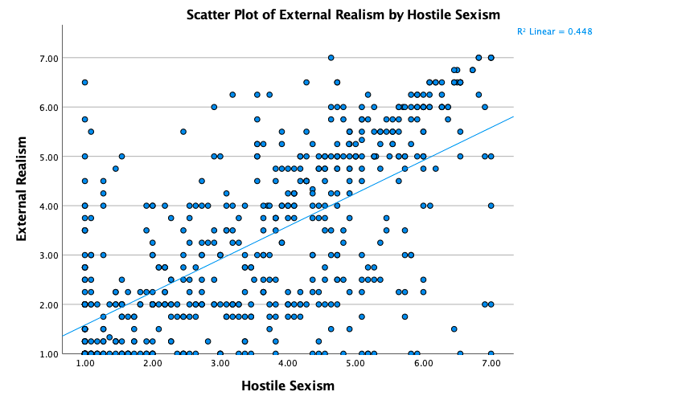

Figure 2. Effects of female journalist stereotypes on external realism.

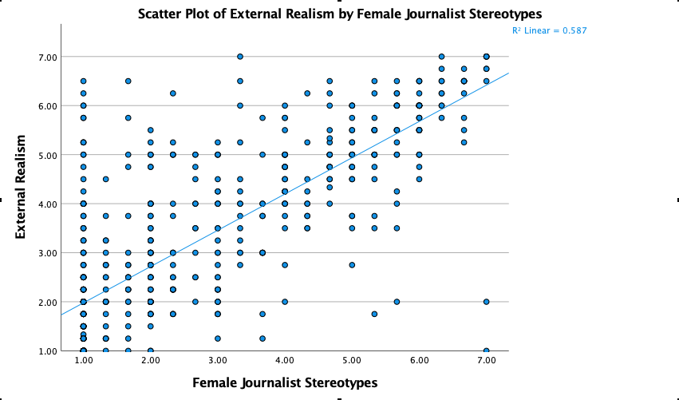

Figure 3. Effects of journalist mistrust on external realism.

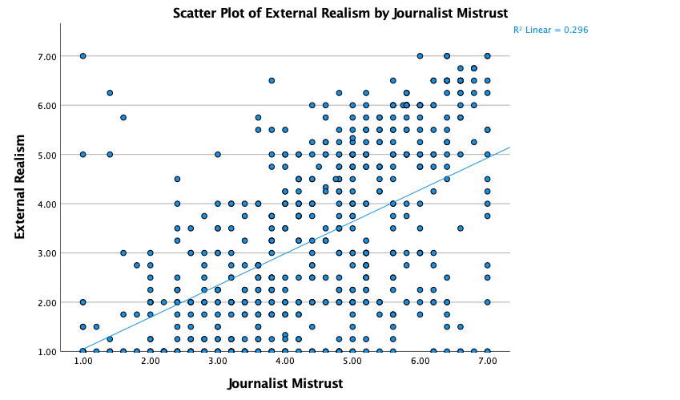

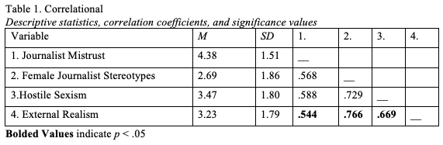

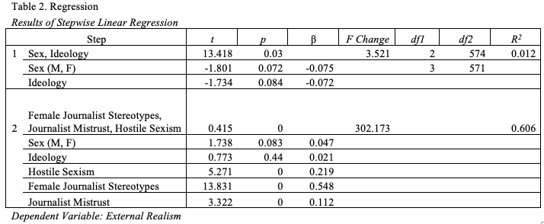

Appendix A

Hostile Sexism

Items on the Hostile Sexism questionnaire. Each was measured on a 1 (“Strongly disagree”) to 7

(“Strongly Agree”) scale.

1. Women exaggerate problems at work

2. Women are too easily offended

3. Most women misinterpret innocent remarks as sexist

4. Women claim discrimination, even when they lose fairly

5. Women use the guise of equality to seek special favors

6. Feminists tend to make unreasonable demands

7. Feminists seek to have more power than men

8. Women seek power by gaining control over men

9. Women like to tease men sexually

Appendix B

Stereotypes of Female Journalists

Items on the Stereotypes of Female Journalists questionnaire. Each was measured on a 1 (“Strongly disagree”) to 7 (“Strongly Agree”) scale.

1. It is common for female journalists to have sex with a source if it gets them a big story

2.Female journalists use their sex appeal to get ahead in the newsroom

3. Female journalists often trade sexual favors for “inside information” from a source

4. Most female journalists have had casual sex with a source to get the interview they need for a

Story

Appendix C

Mistrust of Journalists

Items on the Mistrust of Journalists questionnaire. Each was measured on a 1 (“Strongly disagree”) to 7 (“Strongly Agree”) scale.

1. Most journalists cannot be trusted

2. Most journalists spin the facts to tell the story they want to tell

3. Most journalists will do anything to get a story

4. Most journalists always have their own agenda

5. Most journalists use fake news to trick the public

Appendix D

External Realism

Items on the External Realism questionnaire. Each was measured on a 1 (“Strongly disagree”) to 7 (“Strongly Agree”) scale.

1. The journalist from the video clip was similar to what journalists are like in real life

2. The journalist from the video clip shows what it is like to be a journalist in real life

3. The video clip portrayed the same kind of behaviors that you would see a journalist do in real

life

4. The journalist from the video clip interacted with a source just like a real journalist would

interact with their sources in real life

5. Journalists in real life do not behave at all like the journalist behaved during the video clip